- Load in the dataset
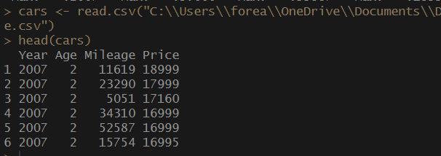
- Visualizations
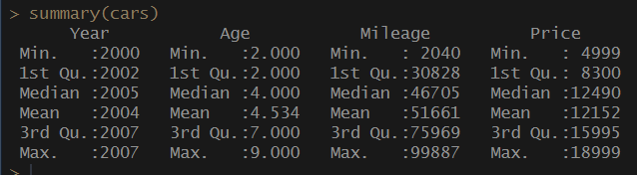
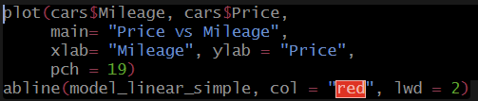
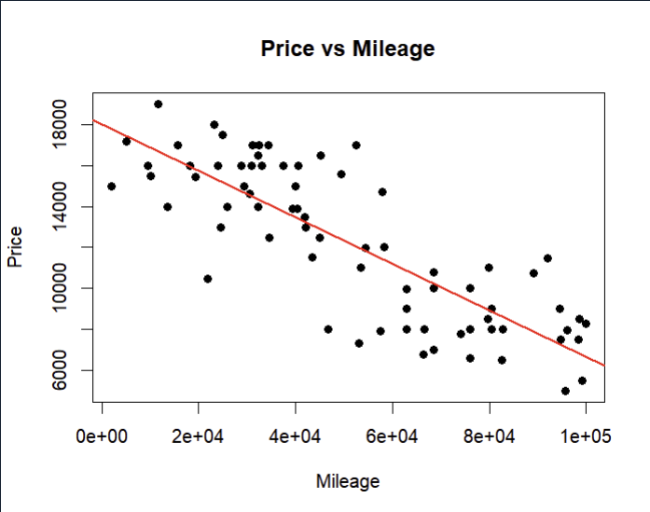
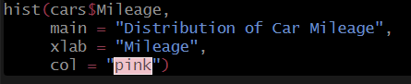
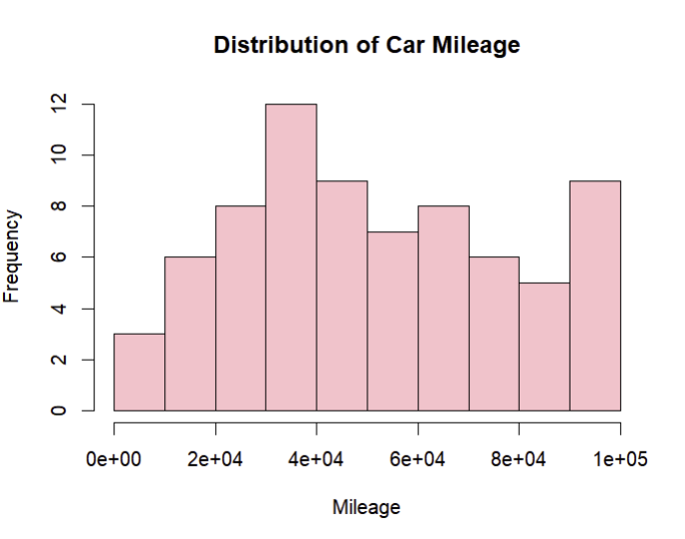

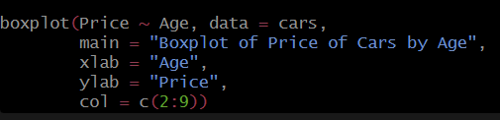
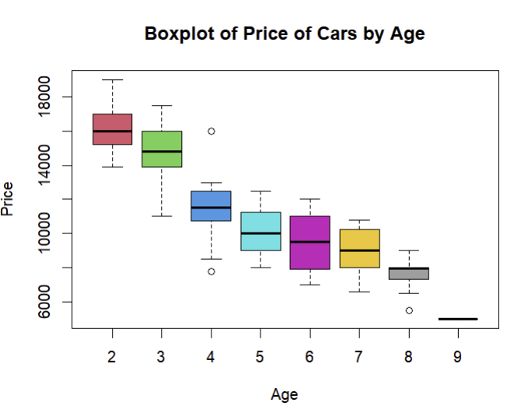
- ANOVA table
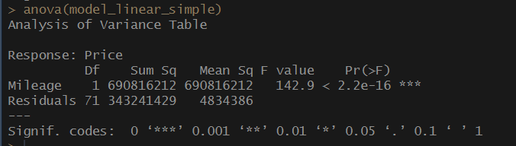
- Predict the resale value price based on the mileage of the Honda Civic
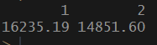

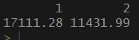
The dataset that I used for homework assignment #7 is called “Honda_Civic_price.csv”. I used this dataset in DSC 325: Essentials of Data Science as an example of Simple Linear Regression. It has 4 variables, year, age, and mileage being the predictor variables and price is the dependent variable. Since it was centralized around simple linear regression, I only needed to use the price and one of the predictor variables. I used mileage since that was what was used for the DSC 325 class example. The point of the simple linear regression was to see if mileage was a strong predictor of car price and to visualize the negative relationship between the usage and value of Honda Civic cars.
For that class, we used Python to analyze the dataset. Because we used Python, I needed to utilize the pandas, plotly, and statsmodel packages to complete the analysis. The outcome was that higher mileage significantly lowers the resale price of a Honda Civic.
Running a similar model in R felt much simpler than it did in Python. I didn’t need to call any packages because they were already built within the R language. I could tell that R is more specialized for statistical modeling and requires less coding to get the same results. The R outputs were also more straightforward and readable compared to the Python equivalent. Even though I’m more familiar with the Python language, R was easier for me to comprehend, and I would want to use it in the future.

I also decided to run a multi linear regression.
Load in the ggplot2 package
